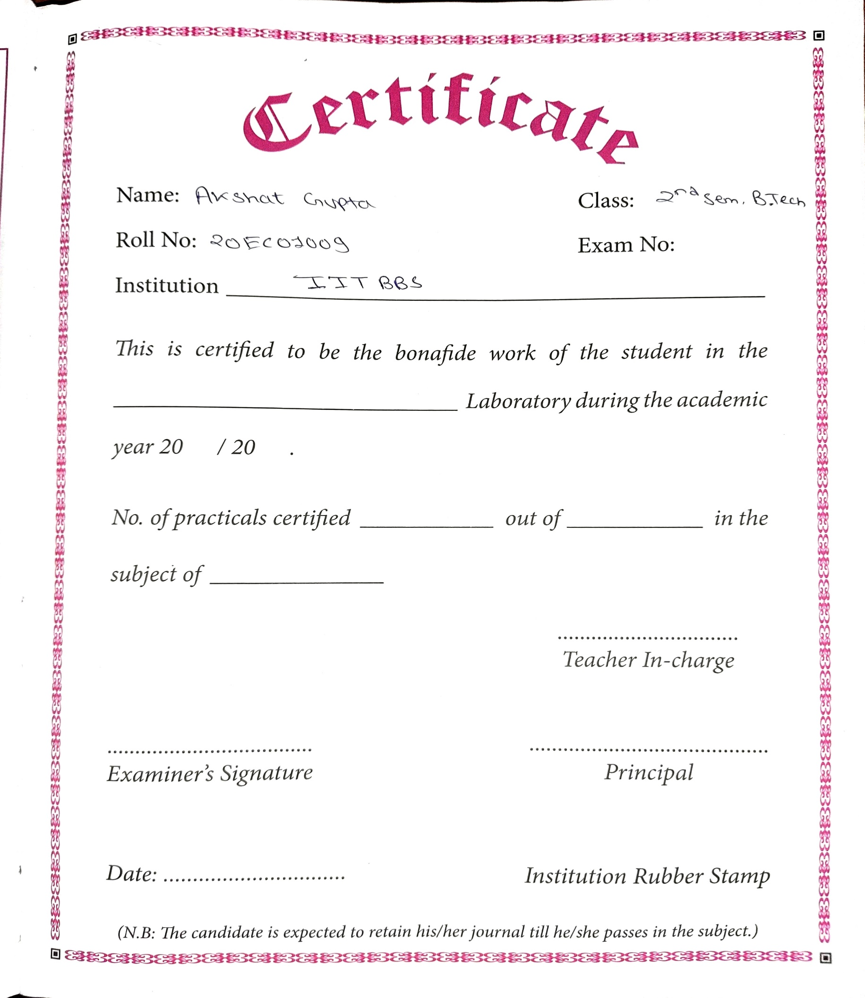

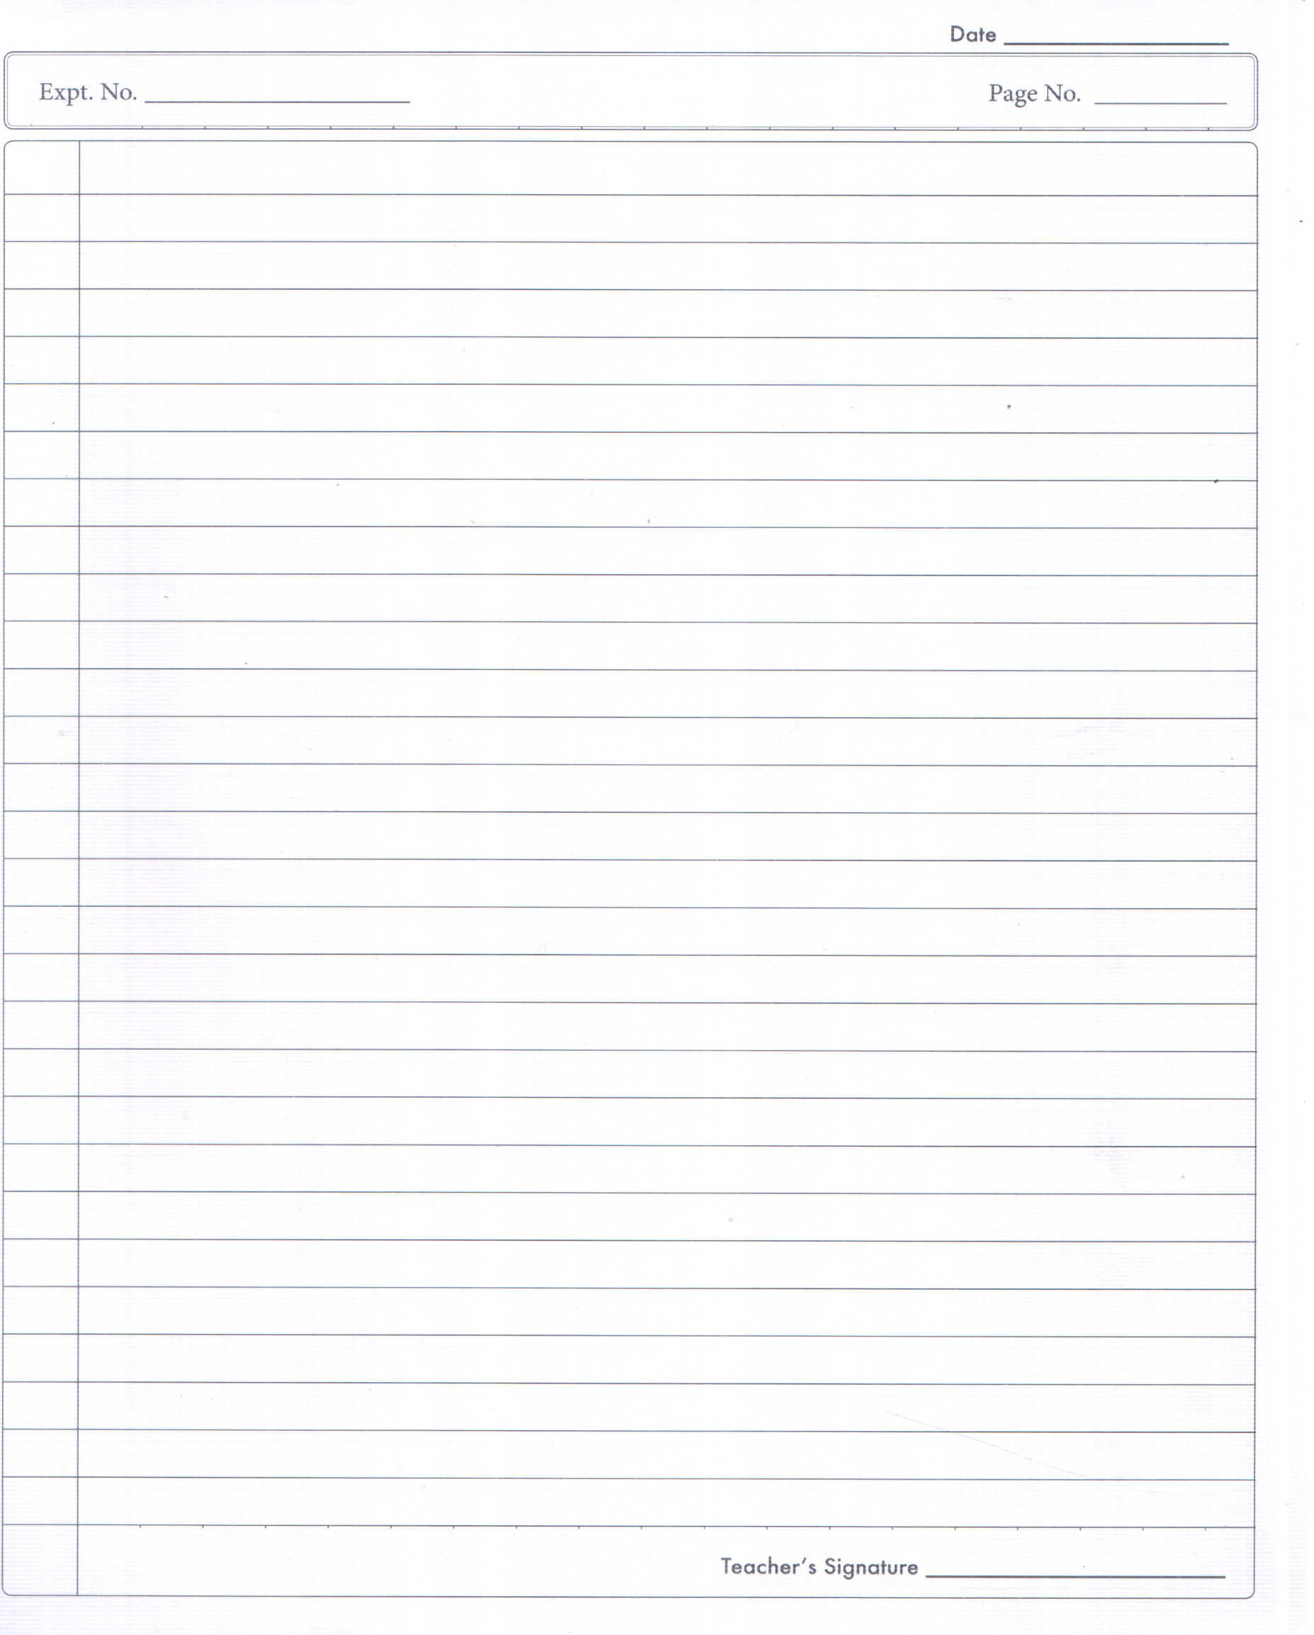**AIM**

**To make V-fit from the given two MS plates and drilling and Tapping as shown in Figure F-E2 Tools required Bench vice, set of Files, Try-square, Scriber, Steel rule, Ball-peen hammer, Dot punch, Hacksaw, Vernier calliper, Surface plate, Angle plate, Vernier height gauge, 5mm drill bit, 3mm drill bit, M6 tap set with wrench, Anvil and Drilling machine. Sequence of operations**

**1. The burrs in the pieces are removed and the dimensions are checked with steel rule.**

**2. Make both pieces surface levels and right angles by fixing in the Vice, use Files for removing material**

**to get level.**

**3. With the help of Try square check the right angles and surface levels.**

**4. Using Surface plate and Angle plate mark the given two metal pieces as per drawing with Vernier**

**height gauge.**

**5. Punch the scribed lines with dot punch and hammer keeping on the Anvil. Punch to punch give 5**

**mm gap.**

**6. Cut excess material wherever necessary with Hacksaw frame with blade, Drill bits and Taps.**

**7. The corners and flat surfaces are filed by using square/flat and triangular file to get the sharp**

**corners. 8. Dimensions are checked by vernier calliper and match the two pieces. Any defect noticed, are**

**rectified by filing with a smooth file. 9. Care is taken to see that the punched dots are not crossed, which is indicated by the half of the**

**punch dots left on the pieces.**

**Result**

**The required V-fitting is thus obtained, by following the stages, as described above.**

**1.1 INTRODUCTION**

**Machine tools are capable of producing work at a faster rate, but, there are occasions when components are processed at the bench. Sometimes, it becomes necessary to replace or repair component which must be fit accurately with another component on reassembly. This involves a certain amount of hand fitting. The assembly of machine tools, jigs, gauges, etc, involves certain amount of bench work. The accuracy of work done depends upon the experience and skill of the fitter.**

**The term 'bench work' refers to the production of components by hand on the bench, where as fitting deals which the assembly of mating parts, through removal of metal, to obtain the required fit.**

**Both the bench work and fitting requires the use of number of simple hand tools and considerable manual efforts. The operations in the above works consist of filing, chipping, scraping, sawing drilling, and tapping.**

**1.2 HOLDING TOOLS**

**1.2.1 Bench vice**

**The bench vice is a work holding device. It is the most commonly used vice in a fitting shop. The bench vice is shown in Figure 1.1.**

**It is fixed to the bench with bolts and nuts. The vice body consists of two main parts, fixed jaw and movable jaw. When the vice handle is turned in a clockwise direction, the sliding jaw forces the work against the fixed jaw. Jaw plates are made of hardened steel. Serrations on the jaws ensure a good grip. Jaw caps made of soft material are used to protect finished**

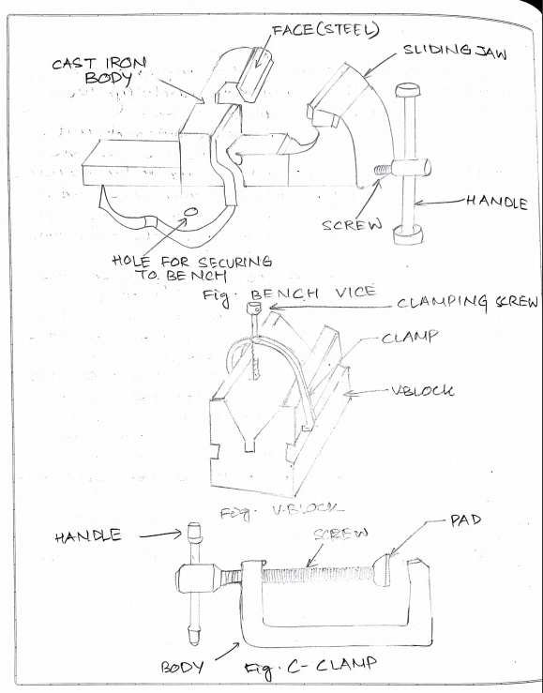 **surfaces, gripped in the vice. The size of the vice is specified by the length of the jaws.**

**The vice body is made of cast Iron which is strong in compression, weak in tension and so fractures under shocks and therefore should never be hammered.**

**1.2.2 V-block**

**V-block is rectangular or square block with a V-groove on one or both sides opposite to each other. The angle of the 'V' is usually 90°. V-block with a clamp is used to hold cylindrical work securely, during layout of measurement, for measuring operations or for drilling for this the bar is faced longitudinally in the V-Groove and the screw of V-clamp is tightened. This grip the rod is firm with its axis parallel to the axis of the v-groove.**

**1.2.3 C-Clamp**

**This is used to hold work against an angle plate or v-block or any other surface, when gripping is required.**

**Its fixed jaw is shaped like English alphabet 'C' and the movable jaw is round in shape and directly fitted to the threaded screw at the end. The working principle of this clamp is the same as that of the bench vice.**

**1.3 MARKING AND MEASURING TOOLS**

**1.3.1 Surface plate**

**The surface plate is machined to fine limits and is used for testing the flatness of the work piece. It is also used for marking out small box and is more precious than the marking table. The degree of the finished depends upon whether it is designed for bench work in a fitting shop or for**

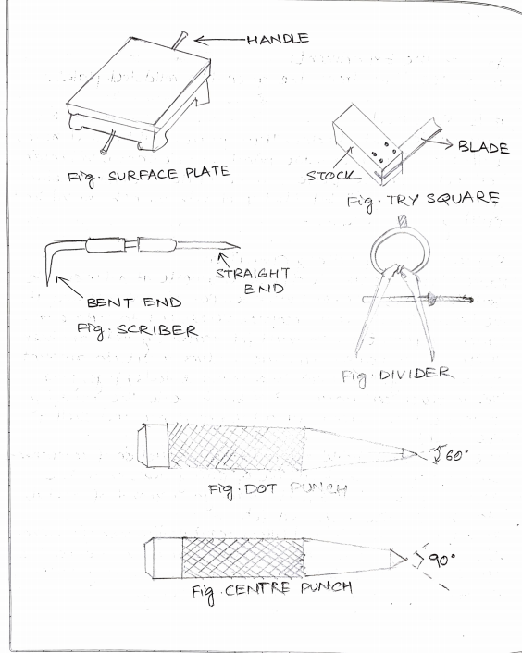 **using in an inspection room; the surface plate is made of Cast Iron, hardened Steel or Granite stone. It is specified by length, width, height and grade. Handles are provided on two opposite sides, to carry it while shifting from one place to another.**

**1.3.2 Try square**

**It is measuring and marking tool for 90° angle .In practice, it is used for checking the squareness of many types of small works when extreme accuracy is not required. The blade of the Try square is made of hardened steel and the stock of cast Iron or steel. The size of the Try square is specified by the length of the blade.**

**1.3.3 Scriber**

**A Scriber is a slender steel tool, used to scribe or mark lines on metal work pieces. It is made of hardened and tempered High Carbon Steel. The Tip of the scriber is generally ground at 12°to 15o. It is generally available in lengths, ranging from 125mm to 250mm .It has two pointed ends the bent end is used for marking lines where the straight end cannot reach.**

**1.3.4 Odd leg Calliper**

**This is also called 'Jenny Calliper' or Hermaphrodite. This is used for marking parallel liners from a finished edge and also for locating the centre of round bars; it has one leg pointed like a divider and the other leg bent like a calliper. It is specified by the length of the leg up to the hinge point.**

**1.3.5 Divider**

**It is basically similar to the callipers except that its legs are kept straight and pointed at the measuring edge. This is used for marking circles, arcs laying out perpendicular lines, by setting lines. It is made of case hardened mild steel or hardened and tempered low carbon steel. Its site is specified by the length of the leg.**

**1.3.6 Trammel**

**Trammel is used for drawing large circles or arcs.**

**1.3.7 Punches**

**These are used for making indentations on the scribed lines, to make them visible clearly. These are made of high carbon steel. A punch is specified by its length and diameter (say as 150' 12.5mm). It consists of a cylindrical knurled body, which is plain for some length at the top of it. At the other end, it is ground to a point. The tapered point of the punch is hardened over a length of 20 to 30mm.**

**Dot punch is used to lightly indent along the layout lines, to locate centre of holes and to provide a small centre mark for divider point, etc. for this purpose, the punch is ground to a conical point having 60° included angle.**

**Centre punch is similar to the dot punch, except that it is ground to a conical point having 90° included angle. It is used to mark the location of the holes to be drilled.**

**1.3.8 Callipers**

**They are indirect measuring tools used to measure or transfer linear dimensions. These are used with the help of a steel Rule to check inside and outside measurements. These are made of Case hardened mild steel or hardened and tempered low carbon steel. While using, but the legs of the calliper are set against the surface of the work, whether inside or outside and the distance between the legs is measured with the help of a scale and the same can be transferred to another desired place. These are specified by the length of the leg. In the case of outside calliper, the legs are bent inwards and in the case of inside calliper, the legs bent outwards.**

**1.3.9 Vernier Callipers**

**These are used for measuring outside as well as inside dimensions accurately. It may also be used as a depth gauge. It has two jaws. One jaw is formed at one end of its main scale and the other jaw is made part of a vernier scale.**

**1.3.10 Vernier Height Gauge**

**The Vernier Height gauge clamped with a scriber. It is used for Lay out work and offset scriber is used when it is required to take measurement from the surface, on which the gauge is standing. The accuracy and working principle of this gauge are the same as those of the vernier callipers. Its size is specified by the maximum height that can be measured by it. It is made of Nickel-Chromium Steel.**

**1.4 CUTTING TOOLS**

**1.4.1 Hack Saw**

**The Hack Saw is used for cutting metal by hand. It consists of a frame, which holds a thin blade, firmly in position. Hacksaw blade is specified by the number of teeth for centimetre. Hacksaw blades have a number of teeth ranging from 5 to 15 per centimetre (cm). Blades having**

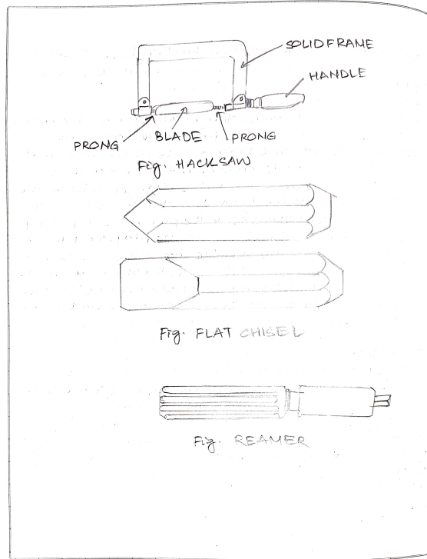

**lessernumber of teeth per cm are used for cutting soft materials like aluminium, brass and bronze. Blades having larger number of teeth per centimetre are used for cutting hard materials like steel and cast Iron.**

**Hacksaw blades are classified as (i) All hard and (ii) flexible type. The all hard blades are made of H.S.S, hardened and tempered throughout to retain their cutting edges longer. These are used to cut hard metals. These blades are hard and brittle and can break easily by twisting and forcing them into the work while sawing. Flexible blades are made of H.S.S or low alloy steel but only the teeth are hardened and the rest of the blade is soft and flexible. These are suitable for use by un-skilled or semi-skilled persons.**

**The teeth of the hacksaw blade are staggered, as shown in figure and known as a 'set of teeth'. These make slots wider than the blade thickness, preventing the blade from jamming.**

**1.4.2 Chisels**

**Chisels are used for removing surplus metal or for cutting thin sheets. These tools are made from 0.9% to 1.0% carbon steel of octagonal or hexagonal section. Chisels are annealed, hardened and tempered to produce a tough shank and hard cutting edge. Annealing relieves the internal stresses in a metal. The cutting angle of the chisel for general purpose is about 60°.**

**1.4.3 Twist Drill**

**Twist drills are used for making holes. These are made of High speed steel. Both straight and taper shank twist drills are used. The parallel shank twist drill can be held in an ordinary self-centring drill check. The tapper shank twist drill fits into a corresponding tapered bore provided in the drilling machine spindle.**

**Taps and Tap wrenches**

**A tap is a hardened and steel tool, used for cutting internal thread in a drill hole. Hand Taps are usually supplied in sets of three in each diameter and thread size. Each set consists of a tapper tap, intermediate tap and plug or bottoming tap. Taps are made of high carbon steel or high speed steel.**

**Dies and die-holders**

**Dies are the cutting tools used for making external thread. Dies are made either solid or split type. They are fixed in a die stock for holding and adjusting the die gap. They are made of Steel or High Carbon Steel.**

**Bench Drilling Machine**

**Holes are drilled for fastening parts with rivets, bolts or for producing internal thread. Bench drilling machine is the most versatile machine used in a fitting shop for the purpose. Twist drills, made of tool steel or high speed steel are used with the drilling machine for drilling holes.**

**Following are the stages in drilling work**

**1. Select the correct size drills, put it into the check and lock it firmly**

**2. Adjust the speed of the machine to suit the work by changing the belt on the pulleys. Use high speed for small drills and soft materials and low speed for large diameter drills and hard materials.**

**3. Layout of the location of the pole and mark it with a center punch.**

**4. Hold the work firmly in the vice on the machine table and clamp it directly on to the machine table.**

**5. Put on the power, locate the punch mark and apply slight pressure with the Feed Handle.**

**6.Once Drilling is commenced at the correct location, apply enough pressure and continue drilling. When drilling steel apply cutting oil at the drilling point.**

**7. Release the pressure slightly, when the drill point pierces the lower surface of the metal. This prevents the drill catching and damaging the work or drill.**

**8. On completion of drilling retrace the drill out of the work and put-off the power supply.**

**FINISHING TOOLS**

**Reamers :**

**Reaming is an operation of sizing and finishing a drilled hole, with the help of a cutting tool called reamer having a number of cutting edges. For this, a hole is first drilled, the size of which is slightly smaller than the finished size and then a hand reamer or machine reamer is used for finishing the hole to the correct size. Hand Reamer is made of High Carbon Steel and has left-hand spiral flutes so that, it is prevented from screwing into the whole during operation. The Shank end of the reamer is made straight so that it can be held in a tap wrench. It is operated by hand, with a tap wrench fitted on the square end of the reamer and with the work piece held in the vice. The body of the reamer is given a slight tapper at its working end, for its easy entry into the whole during operation, it is rotated only in clock wise direction and also while removing it from the whole.**

**Files :**

**Filing is one of the methods of removing small amounts of material from the surface of a metal part. A file is hardened steel too, having small**

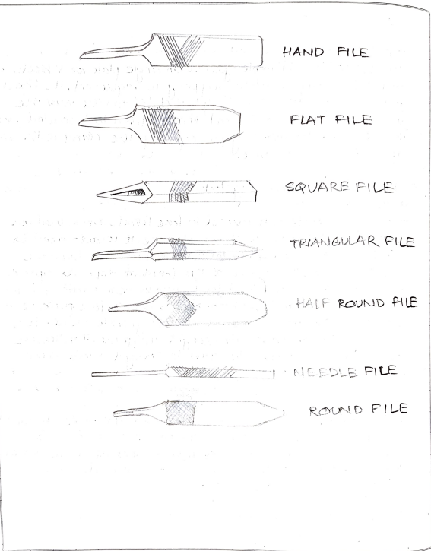

**parallel rows of cutting edges or teeth on its surfaces. On the faces, the teeth are usually diagonal to the edge. One end of the file is shaped to fit into a wooden handle. The figure shows various parts of a hand file. The hand file is parallel in width and tapering slightly in thickness, towards the tip. It is provided with double cut teeth. On the faces, single cut on one edge and no teeth on the other edge, which is known as a safe edge. Files are classified according to their shape, cutting teeth and pitch or grade of the teeth. The figure shows the various types of files based on their shape.**

**Miscellaneous tools:**

**File card**

**It is a metal brush, used for cleaning the files, to free them from filings, clogged in-between the teeth.**

**Spirit level**

**It is used to check the levelling of machines.**

**Ball- Peen Hammer Ball:**

**Peen Hammers are named, depending upon their shape and material and specified by their weight. A ball peen hammer has a flat face which is used for general work and a ball end, particularly used for riveting**

**Cross-Peen Hammer**

**It is similar to ball peen hammer, except the shape of the peen. This is used for chipping, riveting, bending and stretching metals and hammering inside the curves and shoulders.**

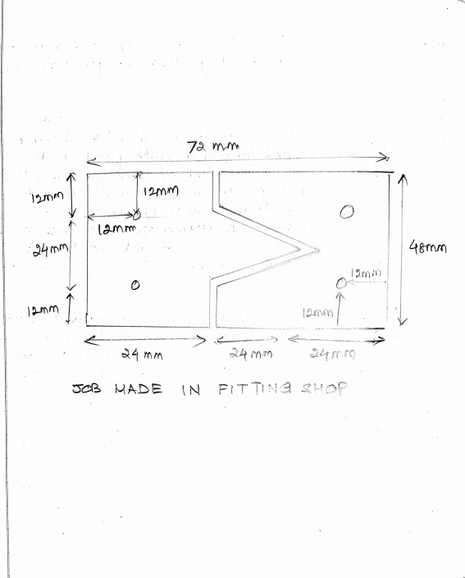

**Straight-Peen Hammer**

**This is similar to cross peen hammer, but its peen is in-line with the hammer handle. It is used for swaging, riveting in restricted places and stretching metals.**

**Screw driver**

**A screw driver is designed to turn screws. The blade is made of steel and is available in different lengths and diameters. The grinding of the tip to the correct shape is very important. A star screw driver is specially designed to fit the head of star screws. The end of the blade is fluted instead of flattened. The screw driver is specified by the length of the metal part from handle to the tip.**

**Spanners**

**A spanner or wrench is a tool for turning nuts and bolts. It is usually made of forged steel. There are many kinds of spanners. They are named according to the application. The size of the spanner denotes the size of the bolt on which it can work.**

**Safe Practice :**

**The following are some of the safe and correct work practices in bench work and fitting shop, with respect to the tools used**

**1. Keep hands and tools wiped clean and free of dirt, oil and grease. Dry tools are safer to use than slippery tools.**

**2. Do not carry sharp tools on pockets.**

**3. Wear leather shoes and not sandals.**

**4. Don't wear loose clothes.**

**5. Do no keep working tools at the edge of the table.**

**6. Position the work piece such that the cut to be made is close to the vice. This practice prevents springing, saw breakage and personal injury.**

**7. Apply force only on the forward (cutting) stroke and relieve the force on the return stroke while sawing and filing.**

**8. Do not hold the work piece in hand while cutting.**

**9. Use the file with a properly fitted tight handle.**

**10. After filing, remove the burrs from the edges of the work, to prevent cuts to the fingers.**

**11. Do not use vice as an anvil.**